And then Jesus dropped the mic as he moved on to Jerusalem.
Eventually we simply come to the realization that God is Trinity:
Three persons in one God; three persons (Father, Son, Holy Spirit) in one Being (God).
And like the 1975 World Series and the 1957 Chevy Bel-Air is a classic and the embodiment of truth.
As we sing our offering hymn, please consider the words, words that say the Trinity is forever by our side, walking our life’s journey with us, and at the end of this life, the Trinity will carry us on to the next life.

Message: Holy Trinity
We struggle with the concept of the Trinity, whether old or young, to understand this mystery of three in one.
A pretzel is made up of one strand of dough but is intricately woven that there are three distinct holes, each one having its own special shape.
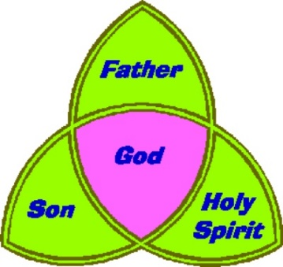
Looking at the clip art of the Holy Trinity, where would we place all human life in this picture? For that matter, all of creation?
Answer: In the center where all three (God the Father, God the Son and God the Holy Spirit) reside.
In theological circles, the Doctrine of the Trinity is like the 1975 World Series or the 1957 Chevrolet Bel-Air Hardtop—a classic and the embodiment of truth.
The 1975 World Series of Major League Baseball was played between the Boston Red Sox (AL) and Cincinnati Reds (NL). In 2003, it was ranked by ESPN as the second-greatest World Series ever played. Cincinnati won the series in seven games.
The 1957 Bel Air remains as one of the most popular models made -- it’s really one of the most popular classics of all time. These models are highly sought after by car collectors and enthusiasts.

As with baseball’s perfect moments or collectable automobiles, controversies arise, passions heat up, and devotees never tire of discussing the mystery of the Trinity.
But how do we sum up the Trinity, God being three persons in one God?

Legend has that St. Patrick demonstrated the Trinity using a shamrock where three distinct leaves comprise a single plant (three in one).Others have borrowed the triune images of light, heat and the sun to explain the Trinity (again three in one).
And others use water where ice is the solid form of water, steam is the vapor form of water, and water is the liquid form (once more three in one).
Like most theological descriptions, neither the word Trinity itself nor the full doctrine of the Trinity occurs in the Bible. But both the word and the doctrine seek to describe accurately the God who is revealed in the Bible.
Theology is always playing a catch-up game—trying to catch up to the reality of who God is.
Doctrine doesn’t make God triune; God is triune.
Our language runs to catch up.

For the first Christians, who had learned from Jesus the Son how to follow God the Father and to expect the coming of God the Holy Spirit at Pentecost, referring to God the Father, Son, and Holy Spirit came naturally.
The New Testament is full of Trinitarian affirmations, such as:
- “The grace of the Lord Jesus Christ, the love of God, and the communion of the Holy Spirit be with you” (2nd Corinthians 13:13).
- “So [Jesus Christ] came and proclaimed peace to you who were far off and peace to those who were near; for through him both of us have access in one Spirit to the Father” (Ephesians 2:17-18).
- “Go therefore and make disciples of all nations, baptizing then in the name of the Father and of the Son and of the Holy Spirit” (Matthew 28:19).
And then there are these two mind-blowing passages that Jesus dropped like a bomb on his disciples:
- “The Father and I are one” (John 10:30).
- And “Whoever has seen me has seen the Father” (John 14:9).
And then Jesus dropped the mic as he moved on to Jerusalem.
Eventually we simply come to the realization that God is Trinity:
Three persons in one God; three persons (Father, Son, Holy Spirit) in one Being (God).
And like the 1975 World Series and the 1957 Chevy Bel-Air is a classic and the embodiment of truth.

