closest friends, yet Martha and Mary struggled to understand Jesus handling of Lazarus’ illness and death.
They probably asked: Why did Jesus not rush to Bethany as soon as he had heard the news? Did Jesus not care? Why would Jesus allow Lazarus to suffer one moment longer than necessary?
Yet each woman—to her credit—expressed continued faith-filled devotion to Jesus. The way Jesus responded to Martha and Mary illustrates two truths that weave a beautiful tapestry of grace.
First, when events don’t go as we think they should, God has a better time and a better way.
Second, God’s perspective is eternal, not earthly.
We tend to view our existence as limited to the seventy or eighty years we have before our bodies can stand no more and then cease to function. God through the Bible assures us that this part of our existence is nothing compared to what we will receive after death.
Say this with me, “God is Good All the Time!”
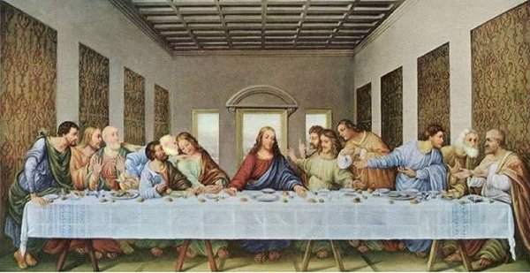
The Story of the Last Supper
Fifth Wednesday in Lent 7 p.m. April 5, 2017 Jesus – Jeff Winkle
Maundy Thursday – 7 p.m. April 13, Last Supper Portrayal & First Communion Service
During this service, twelve individuals will strike the poise of the “Last Supper: painting by Leonardo da Vinci before the communion service. This will be done in reverent silence and last for a few moments allowing the congregation to take time to reflect on the meaning of the “Last Supper” in their life.
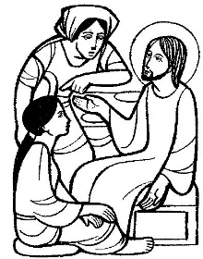
Sermon Insert – Fifth Sunday in Lent
Lenten Message God is Good All the Time! God is not the author or creator of death. Death was never a part of God’s plan for humanity.
Let’s be clear about death:
Death is an inescapable fact of life.
Death is ruthless; it frequently comes without warning, it cannot be cheated, bribed, outwitted, overcome or eluded.
Death is indiscriminate; it takes young and old, poor and rich, sick and healthy, wicked and good.
And death is universal; we will all ultimately surrender to its darkness.
Jesus’ motivation and the decision to go to Bethany: Jesus went to Bethany in a response to God’s design and not out of human need.
It took Jesus four days: one day for the messenger to travel and tell Jesus about Lazarus’ illness, two days of waiting, and one day for Jesus and his disciples to travel to Lazarus. This four day delay served God’s design.
The Jews had a belief, a tradition, that one’s soul, hovered near the deceased body for three days, and after that time there was no hope of resuscitation to life.
The presence of so many Jews gathered around Martha and Mary in mourning, will become active witnesses to the miracle spreading the news about the miracle far and wide.
I wonder if Martha and Mary questioned the goodness of God when Jesus delayed his trip from Jerusalem to Bethany, a distance of a few miles, four days.
What tone of voice would Martha have used, when she said to Jesus, “Lord, if you had been here, my brother would not have died”? Is this a statement of faith that Jesus could have done something? Is it a complaint or a lament or spoken with anger or with sorrow?
The Jews had another belief, they believed that God could give life to the dead. The Jewish Bible, the Old Testament, had examples of God through Elijah (1st Kings 17:7-24) and Elisha (2nd Kings 4:8-37) raising people from the dead.
Martha, as an example of faith, answered her own question when she said, “But even now I know that God will give you whatever you ask of him.”
Martha knows that God will answer Jesus’ prayers. Martha believes in the resurrection of the dead. Martha had listened and remembered Jesus’ words about the resurrection on the last day (John 6:39, 40, 44, and 54). Martha believes that Jesus is the resurrection and the life.
In verse 25, the question about the believers who die before Jesus’ return is answered:
Jesus said to her, “I am the resurrection and the life.* Those who believe in me, even though they die, will live, ²⁶and everyone who lives and believes in me will never die. Do you believe this?”
Often I am asked, “What will happen when I die or a loved one dies?” In the New Testament, Jesus offers answers to this question.
In Luke chapter 20, some Sadducees came to Jesus with a question on resurrection. Their question involved a hypothetical woman married to seven brothers in succession. When all die, including the woman, they ask. “Whose wife will she be at the resurrection?” In trying to trap him in his answer, Jesus uses it as a teaching moment for the Sadducees:
³⁴ Jesus said to them, “Those who belong to this age marry and are given in marriage; ³⁵but those who are considered worthy of a place in that age and in the resurrection from the dead neither marry nor are given in marriage. ³⁶Indeed they cannot die anymore, because they are like angels and are children of God, being children of the resurrection.”
On the same question in the Gospel of Matthew (chapter 22) Jesus said:
³¹ “And as for the resurrection of the dead, have you not read what was said to you by God, ³²’I am the God of Abraham, the God of Isaac, and the God of Jacob’? He is God not of the dead, but of the living.” ³³And when the crowd heard it, they were astounded at his teaching.
This is what Christian faith is all about. Faith in what Jesus’ has commanded and taught.
When I read the story of Martha and Mary’s loss. I take comfort in knowing that I am not alone in my experience. Here are two women who knew the Son of God as personally as I know my

