Who Do You Say That I Am? Fifth Wednesday Service 7 p.m. April 3, 2020
For those who are hearing challenged, Zion has digital listening devices for your use during worship. Please ask an usher or council member for one and they will show you how to use it.
Gathering Call P- As Christians, we have been baptized into the death of Jesus so that we can rise to a new life in him. C- Jesus asked, “Who do you say that I am?” P- What will we do with this man who was falsely accused and suffered a rigged trial, was tortured by Roman soldiers, nailed to the cross, and then laid in a tomb, only to rise again three days later? C- Again, Jesus asked, “Who do you say that I am?”
Our Lenten Cofession
P- God our creator, you know us better than we know ourselves, our failings, insecurities, and sins. God wants us to be open and honest with him, Let us begin in confession. C- Mirrored in your cross, Lord, I see reflected all the sins that crucify you. I see my face in the face of Peter, boasting faithfulness, but my very actions tell the world that I deny you. Lord, I confess to a fickled heart. Help me to be more than a fair-weather Christian. P- I seem y face in the face of Mary, bewildered and shocked by evil’s hate of good. Lord, we admit our own indifference and fear of being too involved, which enhances evil’s power. Strengthen our faith. C- I see my face in the face of the high priest, Caiaphas, the pious hypocrite who used religion to call for the death of the Son of God. Forgive us for playing at religion: making up our own rules of what is right and wrong so that we might appear to be good in our own eyes.
P- I see my face in the face of Mary Magdalene, so confused, while searching to find purpose and meaning. Strengthen us to seek your ways and to trust your care, rather than accepting human made security which is always short lived and fleeting. Help us to trust, C- I see my face in the face of Judas, ready to sell out for a small price. We confess that we are selfish, even greedy for money and things money can buy. Let us never sell anyone short for a price, but give us generous hearts. P- Christ, there is forgiveness in you. I see my face in the face of the Son of God, who gave himself to death for me that I might be forgiven. C- Lord we confess our sin, not only our outward wrongs, but also our failure to do good when we can, and our secret doubts and rebellion against you, P- God our Father sent his Son to us, and for us. Let us live lives worthy of the love, forgiveness, and hope which we have been given. C- Amen! So be it! Thanks be to God!
Scripture Readings

Luke 23:50-56

The Burial of Jesus
Now there was a good and righteous man named Joseph, who, though a member of the council, had not agreed to their plan and action. He came from the Jewish town of Arimathea, and he was waiting expectantly for the kingdom of God. This man went to Pilate and asked for the body of Jesus. Then he took it down, wrapped it in a linen cloth, and laid it in a rock-hewn tomb where no one had ever been laid. It was the day of Preparation, and the sabbath was beginning. The women who had come with him from Galilee followed, and they saw the tomb and how his body was laid. Then they returned, and prepared spices and ointments.
On the Sabbath they rested according to the commandment.
Ephesians 4:12-16
To equip the saints for the work of ministry, for building up the body of Christ, until all of us come to the unity of the faith and of the knowledge of the Son of God, to maturity, to the measure of the full stature of Christ. We must no longer be children, tossed to and fro and blown about by every wind of doctrine, by people’s trickery, by their craftiness in deceitful scheming. But speaking the truth in love, we must grow up in every way into him who is the head, into Christ, from whom the whole body, joined and knitted together by every ligament with which it is equipped, as each part is working properly, promotes the body’s growth in building itself up in love.
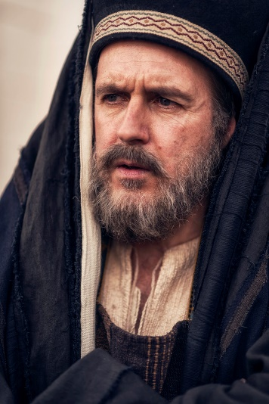
Who Do You Say That I Am?
Dialogue Portrayal – Joseph of Arimathea
A rich man and disciple of Jesus, a respected member of the Sanhedrin council, who was also himself looking for the kingdom of God. As soon as Jesus died on the cross, he asked Pilate for permission to take the body of Jesus for burial.

The Offering (returning a portion of God’s gifts) The Offertory
P- Dear God, C- accept these gifts we offer from you now, as an expression of the faith we place in you. As we place the fruit of our labor into your hands, for the work of your Gospel and service to all your people. Bless us and help us to be generous, as your are generous with us. In Christ’s name we pray. Amen
The Prayers of Our Community
P- O Lord, grant us a quiet night and peaceful sleep. C- Dear Heavenly Father thank you for this journey of Lent. Thank you for our church family and the gift of traveling together as we grow closer to you. Help us to recognize your mercy, your acceptance, and your great love with lives that purpose-filled and joyful.
P- Lord, we come before you, seeking your help. C- Creat growth in our lives. Lead us to new life. Help us to remove thoughts and activities that separate us from you. Give us courage to recognize them and to overcome them.
P- May we take up our CROSS and FOLLOW Christ in the strength of patience, constant faith, and fellowship with him. That we may know the secret of his strength and patience. All of this we pray, in the name of our Savior, who taught us to pray…
The Lord’s Prayer
C- Our Father, who art in heaven,
hallowed be thy Name,
thy kingdom come,
thy will be done,
on earth as it is in heaven.
Give us this day our daily bread;
and forgive us our trespasses,
as we forgive those
who trespass against us;
and lead us not into temptation,
but deliver us from evil.
For thine is the kingdom,
and the power, and the glory,
forever and ever. Amen.
Dismissal
P- It is good to give thanks to the Lord. C- To sing PRAISE to your name!
P- To herald your love in the morning. C- Your truth at the end of the day.
P- Go in peace. Serve the Lord. C- Thanks be to God!
Benediction
Closing Lenten Hymn – Were You There ELW #353

